Minneapolis Community and Technical College
Nursing Faculty Handbook



DRAFT 2017-2018
Welcome to Minneapolis Community and Technical College and the Nursing Program
We are happy you chose to share your wealth of experience and expertise with the students and faculty of our program. The nursing program at Minneapolis Community and Technical College (MCTC) was established in 1970 and has been a significant partner with health care agencies and community throughout the Minneapolis-St Paul metropolitan area. Many of our graduates continue to live and work in Minneapolis-St Paul, representing our program well.

This handbook is best accessed as an electronic document as it has links throughout that are very helpful to you. Throughout the document, you will see reference to the Nursing Student Handbook. The Nursing Student Handbook is found online on D2L Brightspace (D2L) on the “Nursing Message Center.” Just like that, you are able to get even more information about our program, the college and so much more!

We hope this handbook “explains it all” for you, but we are here to help. The best thing about our program is that we are a cohesive and supportive group of faculty and staff and we are here to help you too. Please ASK! If you find something that could be made more clear or is not found in this document (handbook), let us know and offer a suggestion for improvement!

Table of Contents
Overview of Nursing Program Courses
MCTC within the Minnesota State System
Brief History of MCTC and the Nursing Program
Essential Onboarding
Resources Information

Overview of Nursing Program Courses
The MCTC Nursing Program has two (2) cohort types: traditional and advanced standing.
The traditional nursing program is as follows:
SEMESTER 1 (FALL OR SPRING ADMISSION)  NPRO 1000  Introduction to Health Concepts  8 credits: 4 credit theory and 4 credits lab/clinical  2.5 credits lab, 1.5 credits clinical  This course focuses on introducing the Nursing student to the three identified domains of the individual, nursing, and health care. You will learn about concepts within each domain including: evidenced-based practice, ethics, interdisciplinary teams, informatics, communication, managing care, safety, individual-centered care, medication administration, nutrition, assessment, stress/coping, oxygenation, infection and caring interventions. Upon completion, students will be able to provide safe nursing care incorporating the concepts identified in this course. | SEMESTER 2 (FALL OR SPRING)  NPRO 1100  Wellness-Illness Concepts Across the Lifespan  7 credits: 3 credits theory and 4 credits lab/clinical  2 credits lab, 2 credits clinical  This course focuses on further development of the concepts within the three domains of the individual, nursing and healthcare. You will learn about concepts within each domain including: acid-base, cellular regulation, oxygenation, perfusion, inflammation, mobility, sensory perception, sexuality, reproduction, stress/coping, grief/loss, mood/affect, behaviors, development, cognition, self, family, health-wellness-illness, communication, professional behaviors, caring interventions, managing care, safety, and advocacy. Upon completion, you should be able to provide safe nursing care incorporation the concepts identified within this course.  NPRO 1150  Concepts of Health Assessment  3 credits: 1 credit theory and 2 credits lab  This course focuses on performing comprehensive health history and physical examinations. You will learn techniques for performing a head-to-toe physical examination on patients across the life span. You will practice communication skills that enhance data gathering techniques, health teaching and referral skills. These skills enhance your ability and are central to effective nursing interventions and critical thinking.
SEMESTER 3 (FALL OR SPRING)  NPRO 2000  Complex Health Concepts  8 credits: 4 credit theory and 4 credits clinical  This course focuses on further development of the concepts within the three domains of the individual, nursing and healthcare. You will learn about concepts of cellular regulation, metabolism, perfusion, infection, immunity, stress/coping, mood/affect, cognition, self, comfort, behaviors, health-wellness-illness, clinical decision-making, caring interventions, managing care, and safety, quality improvement, and informatics. Upon completion, you should be able to provide safe nursing care incorporating the concepts identified in this course. | SEMESTER 4 (FALL OR SPRING)  NPRO 2100  Synthesis of Health Concepts in Nursing  8 credits: 4 credits theory and 4 credits clinical  This course focuses on the assimilation of the concepts within the three domains of the individual, nursing and healthcare. You will learn about concepts within each domain including: fluid/electrolytes, metabolism, perfusion, mobility, stress/coping, grief/loss, violence, health-wellness, caring interventions, managing care, professional behaviors, collaboration, safety, healthcare systems, quality improvement, advocacy, legal issues, policy, healthcare systems, ethics, accountability, and evidence-based practice. Upon completion, you should be able to demonstrate the knowledge, skills, and attitudes necessary to provide quality, individualized, entry level nursing care.

The advanced standing cohort is for current Licensed Practical Nurses (LPNs) who wish to obtain their associate degree leading to RN licensure. The LPN receives five (5) credits toward their advanced standing admission.
The advanced standing nursing program is as follows:
SEMESTER 1 (SUMMER ONLY ADMISSION)  Semester 1 (Summer)  NPRO 1010  Introduction to Health Concepts  3 credits: 2 credits theory and 1 credit lab  (plus 5 credits= 8 credits toward degree)  This course focuses on introducing the Nursing student to the three identified domains of the individual, nursing, and health care. You will learn about concepts within each domain including: evidenced-based practice, ethics, interdisciplinary teams, informatics, communication, managing care, safety, individual-centered care, medication administration, nutrition, assessment, stress/coping, oxygenation, infection and caring interventions. Upon completion, students will be able to provide safe nursing care incorporating the concepts identified in this course. | SEMESTER 2 (FALL)  NPRO 1100  Wellness-Illness Concepts Across the Lifespan  7 credits: 3 credits theory and 4 credits lab/clinical  2 credits lab, 2 credits clinical  This course focuses on further development of the concepts within the three domains of the individual, nursing and healthcare. You will learn about concepts within each domain including: acid-base, cellular regulation, oxygenation, perfusion, inflammation, mobility, sensory perception, sexuality, reproduction, stress/coping, grief/loss, mood/affect, behaviors, development, cognition, self, family, health-wellness-illness, communication, professional behaviors, caring interventions, managing care, safety, and advocacy. Upon completion, you should be able to provide safe nursing care incorporation the concepts identified within this course.  NPRO 1150  Concepts of Health Assessment  3 credits: 1 credit theory and 2 credits lab  This course focuses on performing comprehensive health history and physical examinations. You will learn techniques for performing a head-to-toe physical examination on patients across the life span. You will practice communication skills that enhance data gathering techniques, health teaching and referral skills. These skills enhance your ability and are central to effective nursing interventions and critical thinking.
SEMESTER 3 (SPRING)  NPRO 2000  Complex Health Concepts  8 credits: 4 credit theory and 4 credits clinical  This course focuses on further development of the concepts within the three domains of the individual, nursing and healthcare. You will learn about concepts of cellular regulation, metabolism, perfusion, infection, immunity, stress/coping, mood/affect, cognition, self, comfort, behaviors, health-wellness-illness, clinical decision-making, caring interventions, managing care, and safety, quality improvement, and informatics. Upon completion, you should be able to provide safe nursing care incorporating the concepts identified in this course. | SEMESTER 4 (FALL)  NPRO 2100  Synthesis of Health Concepts in Nursing  8 credits: 4 credits theory and 4 credits clinical  This course focuses on the assimilation of the concepts within the three domains of the individual, nursing and healthcare. You will learn about concepts within each domain including: fluid/electrolytes, metabolism, perfusion, mobility, stress/coping, grief/loss, violence, health-wellness, caring interventions, managing care, professional behaviors, collaboration, safety, healthcare systems, quality improvement, advocacy, legal issues, policy, healthcare systems, ethics, accountability, and evidence-based practice. Upon completion, you should be able to demonstrate the knowledge, skills, and attitudes necessary to provide quality, individualized, entry level nursing care.

MCTC within the Minnesota State System
MCTC is a member school of Minnesota State (formerly Minnesota State Colleges and Universities [MnSCU]). In 1995, the Minnesota legislature issued legislation that restructured Minnesota’s college and university system and founded a new higher education system, Minnesota State Colleges and Universities (MnSCU, rebranded as Minnesota State in 2017) which placed all public community colleges, technical colleges, and universities (excluding the University of Minnesota) under its supervision. The Minnesota State Chancellor and Board of Trustees provide oversight of the Minnesota State System. Minnesota State currently includes thirty (30) state colleges and seven (7) state universities.

Minnesota State Mission
The Minnesota State Colleges and Universities system of distinct and collaborative institutions offers higher education that meets the personal and career goals of a wide range of individual learners, enhances the quality of life for all Minnesotans and sustains vibrant economies throughout the state.

MCTC Mission
Minneapolis Community and Technical College provides access to the transformative power of education in a diverse and dynamic downtown environment.

Nursing Program Mission
The Associate Degree Nursing Program provides educational opportunities for diverse learners to acquire the necessary knowledge, skills, values and competencies for safe nursing practice. The program is designed to provide excellent nursing education to improve the health and wellness of the multicultural community. The program offers a collegiate nursing curriculum that promotes continuance of education at a 4-year institution and lifelong learning. Graduates will receive the associate of science degree in nursing and are eligible to sit for the National Council Licensure Examination for Registered Nurses (NCLEX- RN).

Brief History of MCTC and the Nursing Program
- Minneapolis Community and Technical College (MCTC) is a public two-year college located in the heart of downtown Minneapolis, Minnesota on over twenty (20) acres of land.
- MCTC was created in 1996, as the result of the merger of two institutions: a technical college (Minneapolis Technical College) with a long history of vocational education dating back to 1914; and an open-enrollment community college (Minneapolis Community College) established in 1965.
- MCTC’s student body is one of the most diverse in the State of Minnesota (public and/or private) with 61% students of color. More than 80 languages and dialects are spoken on campus. MCTC’s Fiscal Year (FY) 2016 enrollment was 12,326; with 27% first generation college students, 66% receiving financial aid, including 43% Pell Grant recipients (Retrieved from MCTC Campus Fact Sheet, https://www.minneapolis.edu/About-Us/Fact-Sheet).
- In 2017-2018, MCTC has reorganized the college into a schools model. Nursing now resides in the School of Nursing, Health Sciences, and Public Services.
  - This school model allows students interested in a healthcare related career to be able to have options for a certificate, diploma, or associate degree in a number of fields of study.
- MCTC’s nursing program enrolls 96 students per year, and generally there are 150 to 190 students enrolled annually.
  - The majority of nursing students have completed most, if not all, of the general education course requirements prior to beginning the nursing program.
- Since 2013, students are provisionally dually admitted to Augsburg University in a Bachelor of Science in Nursing (BSN) completion program.
- The MCTC Associate Degree Nursing Program was initially accredited in November 1975, and has been continuously accredited since that time.
  - Accreditation visits are conducted every eight (8) years. The dates of the last accreditation visits by the Accreditation Commission for Education in Nursing (ACEN) was February 9-11, 2010; and February 27, 28, and March 1, 2018.
- When the Associate Degree Nursing Program began in 1970, MCTC also had a Practical Nursing (PN) Program.
  - Before the community and technical college merged in 1996, the two programs functioned separately.
  - In 1998, after the community and technical college merged, the Associate of Science in Nursing and Practical Nursing Programs remained as separate programs administered by one nurse administrator.
    - In 2002, the Practical Nursing Program and the Associate Degree Nursing Program merged into a career ladder pathway.
    - From 2002 to 2013, the MCTC Nursing Program was a four-semester career ladder pathway, including both Practical Nursing and Associate Degree Nursing graduates. This career ladder model ended in 2013, with the discontinuation of enrollment into the Practical Nursing Program.
- In fall 2013, the revised Associate of Science in Nursing (ASN) Program then began utilizing a new concept-based curriculum.
  - The remaining Practical Nursing students had the opportunity to complete the career ladder pathway model, and the Practical Nursing Program at MCTC voluntarily closed effective June 1, 2015, when the final Practical Nursing Program students graduated in May 2015.
  - Today, MCTC has a single nursing program type; the Associate of Science in Nursing Degree Program offered at one single location, MCTC.
Essential Onboarding
- You will receive a welcome email to your personal email (provided in the interviewing process).
  - This email must be opened and directions followed, which includes completing a secure form via the email.
    - You will not be entered into the MCTC system until you have completed this action.
- You will receive your unique StarID.
  - You StarID is your login to technology and all MCTC web accessed sites.
    - Your StarID is letters and numbers: e.g. ab1234bc
    - When logging in you use starID@minneapolis.edu
      - E.g. ab1234cd@minneapolis.edu
- Once you are entered into the MCTC system and receive your StarID, you will need to get your photo identification (MCTC Campus Card) located in the Helland Center 1st floor at the C-Store.
  - The MCTC Campus Card is used as your identification at the school and in clinical settings.
  - OPTIONAL: You are able to load money for PARKING in the MCTC Parking Ramp via the Campus Card login site from the “Employee” tab on the MCTC homepage.
    - Parking money loaded onto your Campus Card allows you to park in the parking ramp for $2.50 per day (includes ins and outs) vs. the regular (non-Campus Card) $5.00 daily rate.
  - OPTIONAL: You are able to load money for CAMPUS CASH via the Campus Card login site from the “Employee” tab on the MCTC homepage.
    - Campus Cash is accepted at Dunn Bros. Coffee in the T. Skyway and at Tiffin Man (the main cafeteria) located on in the Technical Building (T.) 1st floor.
- You will be assigned an office on Helland (H.) 5th floor and an office phone number.
  - Once the office assignment is made, you will receive the appropriate keys for your office and the T. 5th floor Nursing Lab.
- You will discuss and receive your teaching assignment from the Director of Nursing.

Resources Information
There are many online resources utilized by MCTC. The MCTC website is www.minneapolis.edu
The majority of resources you will utilize are listed on the MCTC website under the tab in the upper right for employees titled “Employees”
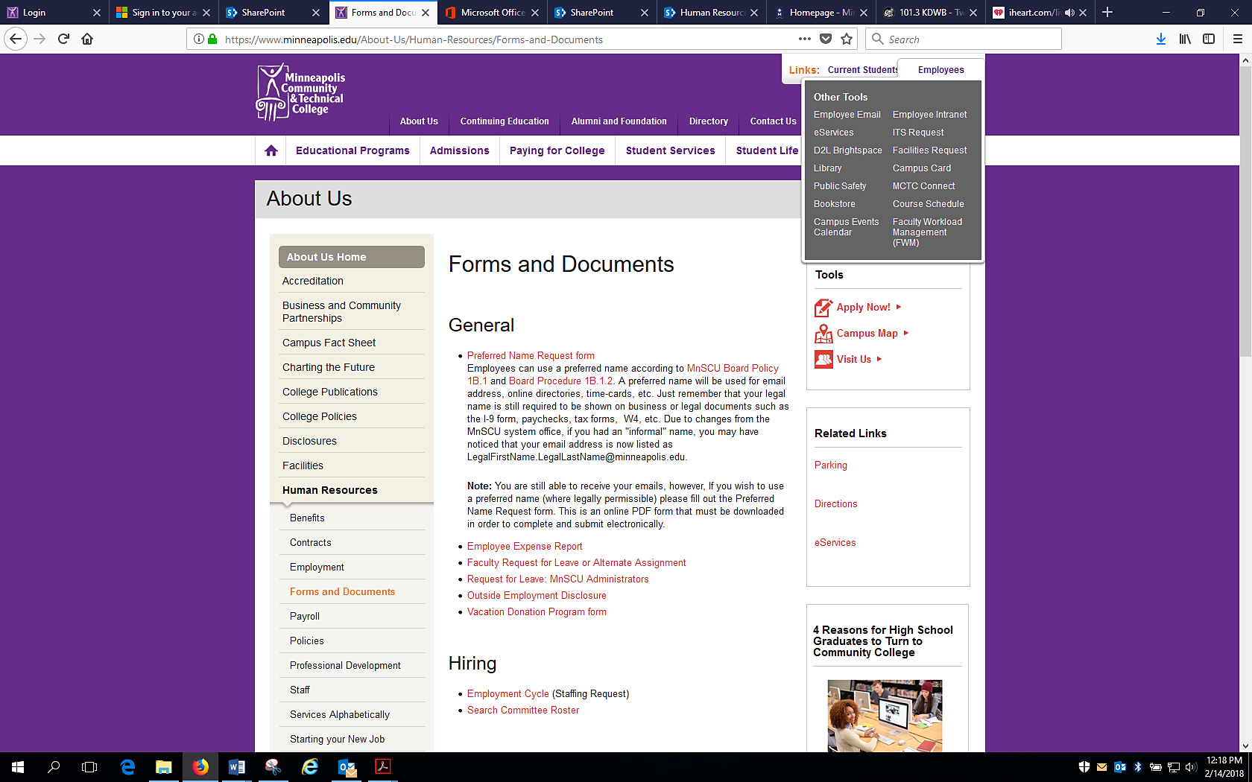

From this “Employees” tab you are able to access:
- “Employee Email” takes you to your email within Microsoft Office 365.
  - Office 365 includes:
    - OneDrive
    - SharePoint
    - MS Office Suite programs
      - Word
      - PowerPoint
      - Excel
- “eServices” takes you to the login for the Integrated Statewide Records System (ISRS) which has functions specifically for faculty:
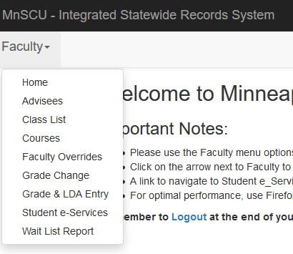

- “D2L Brightspace” which is the learning management system (LMS) platform used for delivering course content in online and blended classes.
  - All nursing courses utilize D2L for course content and communication.
  - D2L pages are courses specific, except for two sites managed by the Director of Nursing:
    - “Nursing Message Center” site for all nursing program students and nursing faculty and staff.
      - Program-wide information is posted on the Nursing Message Center.
    - “Nursing Faculty” site for all nursing faculty and staff.
      - Course materials from previous years and semesters are posted on the Nursing Faculty site.
- “Library” takes you to the MCTC Library Page.
  - Online journals and resources can be accessed via the library.
- Public Safety: general information about public safety
- Bookstore: college bookstore site, store is located on T. 1st floor
- Campus Events Calendar: campus happenings
- Employee Intranet
- ITS Request: for any technology issues and/or needs
- Facilities Request
- Campus Card
- MCTC Connect: college news and happenings
- Course Schedule: takes you to the course lists for the college
- Faculty Workload Management (FWM)

Additional Items to add:
Assessment Technologies, Inc (ATI)
Lippincott CoursePoint for Nursing Concepts

Minnesota State College Faculty (MSCF) Contract: https://www.mscfmn.org/mscf-contracts

Employee Intranet
Employee Forms
https://my.minneapolis.edu/login
https://my.minneapolis.edu/Administrative/Employee-Forms-and-Documents

SharePoint
portal.office.com to login to Office 365
OneDrive

Clinical Sites

SharePoint Human Resources site has many has many valuable resources.
https://minneapolisedu.sharepoint.com/HR/SitePages/Home.aspx

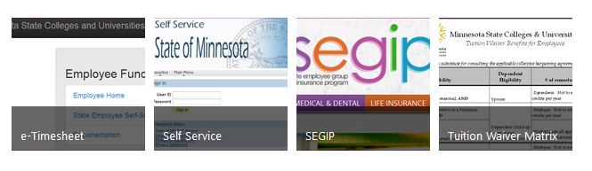

These include links to eTimesheet, State of Minnesota Self-Service, SEGIP (benefits) and Tution Wiaver information.

Faculty Handbook Ideas:
- Parking and mileage reimbursement
- Keeping student confidence in allegation instances: suicidal, homicidal, abuse, law infringement
- E-mail communication to students
- D2L expectations- using a course shell
- Turnaround time on assignments
- Office hours
- Semester Kick-off
- Orientation and final semester messaging
- Meeting requirement
- SNA
- TEAS test proctoring
- Ordering textbooks
- Personal leave- sick day
- Academic calendar
- Current faculty
- End of semester activities- Pinning ATI Live Review
- Graduation application for students
- Progression
- Complaints for students
- Union
- Understanding credits and contact hours

Behavioral Expectations:
- Regular and consistent attendance at work.
- Meets all assigned classes as scheduled.
- Effectively organize and prepare learning activities for assigned courses in accordance with established syllabi.
- Prepare and maintain accurate course syllabi and course handouts for each course taught.
- Evaluate and record student performance/achievement on a regular basis and provide regular student feedback.
- Participate in student learning assessment and program evaluation projects.
- Maintain established office hours and meet with students as necessary.
- Must maintain compliance with required trainings as designated by supervisor.
- Participate in the development and/or execution of departmental tasks and projects in the area of instruction or instructional support (i.e. program evaluation, department reports).
- Assist in the process of acquiring and maintaining appropriate materials, equipment, and supplies to support the learning environment in established department courses.
- Collaborate in the development, assessment, and revision of curriculum.
- Through committee participation and department meetings, participate in the formulation, interpretation, and application of policies and procedures.
- Regularly engage in professional learning activities and actively seek information about developing trends and ideas.
- Maintain currency of professional skills.
- Assist in the planning, development, and coordination of semester course schedules.
- Assist in articulation activities with other educational institutions.
- Render service, when possible, to the college and community.
- Perform related duties as assigned.
- Be able and willing to represent the College in the most positive manner with prospective, former and current students, clients, suppliers, and the community we serve.
- Possess the ability to organize and present various concepts to a wide range of students with varying backgrounds and abilities, and adjust teaching techniques accordingly.
- Be able and willing to deliver courses in alternative delivery times and methods as needed by the department, including evening, guided self-study, Internet, and ICN courses.
- Manage a classroom setting in a way or manner that is acceptable and consistent with department and College objectives, guidelines, policies and practices.
- Assume responsibility for the instructional setting including dealing effectively with problems and exercising independent judgment.
- Maintain a minimum of five office hours per week, and be available on an as needed basis for student questions and discussions regarding their performance.
- Possess a working knowledge of personal computers and educational media equipment.
- Be a creative, energetic, and self-motivated individual who demonstrates leadership and collaborative work habits within the department and in active participation in college committees.
- Establish and maintain good working relationship with students, colleagues, staff, administrators, and general public.
- Read, understand, and express oneself clearly and effectively in oral and written form.
Possess strong human relations skills. Interact well with diverse personalities.
- Participate regularly in professional learning activities such as internal and external workshops, conferences, and/or individual research projects.
- Perform in a manner which strengthens the coordination and cooperation of all organizational components of the College, including opportunities for student recruitment.
- MCTC Core Principles: All employees are expected to adhere to all MCTC policies and procedures. MCTC administration, faculty, and staff value a positive working environment and an environment of mutual respect, therefore all employees are to maintain a positive attitude and respect for others when working with all MCTC departments, employees, students, partners, and the public.

